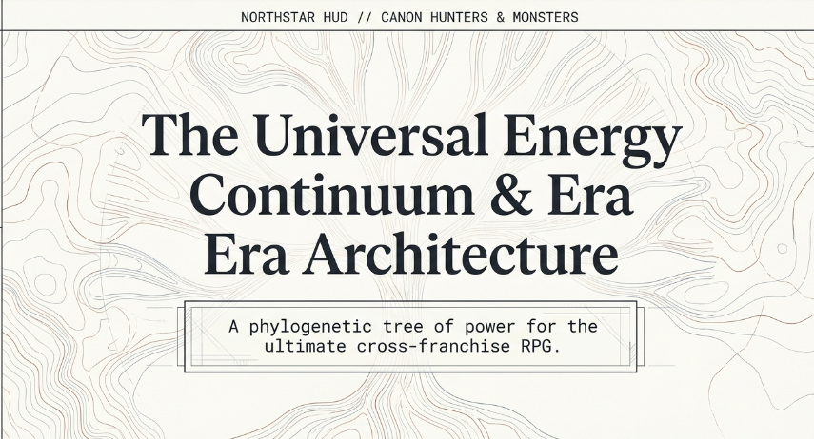
Pokemon with anime power systems based on real BST’s and in game mathematics and calculations
Canon Hunters and Monsters World is a layered, age-stratified monster RPG where Breath, Bending, Word/Resonance, Chakra, Nen, and Cursed Energy are not separate magic systems — they are historical dialects of one fundamental force.
Each age changes the world’s technology, social organization, monster ecology, power ceiling, and legal squad-battle structure.

Age | Lore Anchor / Inspiration | World Condition | Energy Dialect | Power Ceiling | Gameplay Function
Age 0: Source / Pre-Canon | Original myth layer | Primordial world, unnamed forces | Raw Will / Canon Field | Undefined | Explains why all later systems feel related
Age 1: Breath & Bend Age | Demon Slayer + Avatar | Low-tech, martial/spiritual traditions, human body limits | Breath, Bending, early Word/Resonance | Human-capped, elite warriors peak below modern disasters | Teaches typing, stamina, elemental identity
Age 2: Venia–Nocturne West | Castlevania-like western derivation | Gothic west, churches, alchemy, bloodlines, moonlit castles, early firearms/steel | Holy, Blood, Nocturne, Steel, Alchemical Spirit | Still human-capped, but ritual/relic amplification exists | Bridges personal combat into monster-hunting institutions
Age 3: Chakra–Nation Age | Naruto + Shippuden | Organized villages/nations, seals, infrastructure, societal war machines | Chakra, Yin/Yang, Sealing, Tailed/Beast energy | Society scales power; elite individuals become regional weapons | Introduces team logistics, seals, summons, large-scale threats
Age 4: Nen New World | Hunter x Hunter | Modern world rising from ashes, exploration, associations, nen beasts | Nen, Aura, Contracts, Hunter licensing | Individual ceilings rise sharply; institutions regulate extremes | Makes “hunter” identity official; introduces rule-based abilities
Age 4+: Curse Modernity | Jujutsu Kaisen | Urban modern world, cursed objects, special grades, hidden disasters | Cursed Energy, Domains, Binding Vows, Curse Techniques | Special grades become walking catastrophes, but still not Dark Continent tier | Evolves Hunter Association logic into urban disaster response
Age 5: Dark Continent / Forbidden Zone | HxH Dark Continent concept, original expansion | Unknown land beyond normal canon law | Nonstandard / anti-canon energy | Above normal squad legality | Postgame / restricted zone; not for side characters or standard teams

- Canon Field
- Source Will
- Hive Breath
- Resonance
- The Narrative Force
- Canon Energy
Canon Hunters, I like Canon Field best.
Canon Field definition
The Canon Field is the underlying reality-layer that living beings interpret through culture, biology, spirituality, emotion, and technology.
Breath, Bending, Word Magic, Chakra, Nen, and Cursed Energy are not separate systems. They are era-specific dialects of the same field.
Dialect map
Dialect | Expression | Source Inspiration | Core Theme
Breath | Body, lungs, nervous system, sword forms | Demon Slayer | Physical discipline converts life force into technique
Bending | Element, stance, flow, environment | Avatar | Will shapes external matter/spirit
Word / Resonance | Voice, mantra, true name, sound | “speaker magic” idea | Language vibrates the Canon Field
Chakra | Spiritual + physical energy, seals, networks | Naruto | Energy becomes infrastructure
Nen | Aura, life energy, contracts, specialization | Hunter x Hunter | Individual will becomes rule-bound power
Cursed Energy | Negative emotion, objects, domains, vows | Jujutsu Kaisen | Psychology becomes weaponized reality
This is very strong because it lets you say:
A Breath user and a Nen user are not using different magics.
They are using the same Canon Field through different historical technologies of self-control.

“Muzan plus tier and ignoring Nichirin only sunlight only game-breaking incompatibility as I see the fundamental forces as the energy thingy equivalent”
Yes. This is important.
Do not make sunlight an instant-delete button. That breaks team battles and makes older eras feel stupid.
field condition.

Rule: No universal insta-kill from one element
Solar/Holy light based derivations should be powerful against Demon, Blood, Undead, Nocturne, and Curse-aligned monsters, but not absolute.
Example:
Condition | Effect
Daylight Field | Solar/Holy moves +25% power always last 7 turns in game showdown battle
Solar Exposure | Demon/Blood/Undead regen reduced by 30% in said last 7 turns in 10 turn seasonal intervals
Purified Sunlight | First 3 turns are dark / nighttime as darkness and evil is easy 3 turns after comes daylight, Undead/Demon types gain “Scorch” status
Progenitor/Demon King tier | Can survive Solar exposure with high Will/Regen, but takes cumulative strain
So sunlight becomes a tactical environment, not a cheat code.
That preserves balance.

Better canon phrasing
“Sunlight does not erase demons. It forces their Canon signature into a higher-frequency state they cannot sustain indefinitely.”
That sounds much more original and system-based.

4. Power tiers and BST ranges
Since you want Pokemon-like typing + base stat totals, you need a clean BST ladder.
Here is a working framework.

Rank / BST table
Rank | BST Range | Meaning | Example Role
Initiate | 280–350 | Young, unrefined, local threat | Starter-tier monster
Hunter | 350–430 | Trained, dangerous to normals | Early-game ally
Veteran | 430–500 | Experienced, regional threat | Mid-game squad core
Elite | 500–570 | Peak of normal age structure | Late-game non-legendary
Master | 570–640 | Age-defining expert | Boss / ace monster
Calamity | 640–720 | Regional disaster | Demon lord / tailed beast tier
Disaster / Special Grade | 720–790 | Walking catastrophe | Gojo/Sukuna/special-grade analog
Anomilies of special grades | 790–880+ | Outside normal canon law | Dark Continent / postgame entity and the legendaries

5. Age ceilings vs individual outliers
Important distinction:
Age sets the normal ceiling. Rank sets the individual outlier.
So Age 1 is human-capped, but a Progenitor Demon can exceed the normal Age 1 ceiling.
Example:
Age | Normal Max BST | Outlier Max BST | Notes
Age 1: Breath & Bend | 540–570 | 620–660 | Demon King / Progenitor tier can break ceiling but has environmental weaknesses
Age 2: Venia–Nocturne | 570–600 | 640–680 | Castle lords, blood saints, alchemical relics
Age 3: Chakra–Nation | 620–660 | 700–740 | Tailed beast / demon lord / Kage-plus tier
Age 4: Nen New World | 660–720 | 740–780 | Association elites, nen beasts, master hunters
Age 4+: Curse Modernity | 700–760 | 780–820 | Special grades, domain users, cursed objects
Age 5: Forbidden | 800+ | 880+ | Not standard squad-legal
This lets Muzan-plus exist without making every Demon Slayer character irrelevant.
A Progenitor Demon can be Calamity-tier, but a modern Special Grade can still be Disaster-tier. The difference is not “old weak, new strong.” The difference is:
Older eras are limited by body, ritual, and environment.
Newer eras are limited by rules, contracts, psychology, and public containment.

6. How Naruto fits as the “next great era”
You described Naruto/Shippuden as:
“the next great era and the evolution of human society and technology of the fan eras”
Yes. That is the correct framing.
Age 3 should not just be “stronger breathing.” It should be the moment where energy becomes social infrastructure.

Age 3 identity
Feature | Meaning
Villages / nations | Power becomes organized
Seals | Energy becomes storable and transferable
Chakra networks | Bodies become living circuits
Summons / tailed beasts | Monsters become strategic assets
War / peace cycles | Society begins controlling catastrophic individuals
This is the bridge between:
- Age 1/2: individual mastery, local myths, human limits
- Age 4/4+: institutional modernity, rule-based abilities, urban disasters
So Naruto-era is not just “chakra turned up.” It is:
the industrialization of the Canon Field.
That is a great design theme.

7. How Hunter x Hunter and JJK fit as the modern layer
You said:
“Hunter x Hunter and Jujutsu Kaisen seem like the modern world from the ashes but Hunter x Hunter as the new world and their nen beasts then Jujutsu Kaisen is new world plus still not dark continent for side characters really but mains like Mei Mei, Gojo, disaster curses, Yuta, Sukuna and other special grades are like the Hunter Association evolved”
Yes. I see it.

Age 4: Nen New World
This is the era of:
- exploration
- licenses
- associations
- contracts
- nen beasts
- individual potential becoming measurable
- the world expanding beyond old maps
Gameplay function:
Age 4 teaches the player that power is not just elemental. Power is rule-based.
Nen abilities should feel like “monster skills with conditions.”
Examples:
Nen-style mechanic | Game effect
Contract | Strong move, but failure causes HP/accuracy penalty
Restriction | Lower stats, but boosted critical or priority
Aura Reinforcement | Defensive stance that drains stamina
Nen Beast | Wild modern monster with unstable type profile
Hunter License | Access to restricted zones / quests

Age 4+: Curse Modernity
This is the “new world plus.”
It is not a totally separate age. It is the modern layer after the world has become urban, hidden, psychologically dense, and cursed by its own leftovers.
Gameplay function:
Age 4+ teaches that power can become conceptual, emotional, and territorial.
Curse mechanics should feel more dangerous and less sport-like than Nen.
Examples:
Curse-style mechanic | Game effect
Cursed Object | Monster gains high power but corrupts squad bond
Binding Vow | Trade HP/stat for massive move boost
Domain Expansion | Temporary field that overrides normal type matchups
Special Grade | Boss-tier unit with restricted squad legality
Urban Curse Zone | Environment changes every turn
But crucially:
Special grades are not Dark Continent tier.
They are the evolved Hunter Association extreme, not the final unknown.
That keeps your power ladder clean.

8. Dark Continent should be postgame, not side-character content
You said:
“still not dark continent for side characters really”
Yes.
The Dark Continent / Forbidden Zone should be treated as a canon boundary.
It should not be accessible to:
- normal hunters
- side squads
- standard story companions
- regular capture mechanics
It should be reserved for:
- main-story endgame
- special expedition squads
- rule-breaking monsters
- temporary allies
- nonstandard capture/bind systems

Dark Continent design rule
The Dark Continent is not just “another map.”
It is an area where the Canon Field stops behaving like the rest of the world.
Gameplay effects:
Dark Continent Rule | Effect
Type Instability | Some type matchups invert randomly
Capture Failure | Standard binds fail unless special relic used
Stat Distortion | BST may temporarily exceed normal cap
Squad Strain | Each turn outside canon law damages bond stability
Forbidden Entities | Cannot be permanent party members without major story cost
This makes the Dark Continent feel genuinely alien.

9. Typing system direction
For a Pokemon-like game, you need a type chart, but I would not start with 18 random types. Start with a smaller, canon-driven set.

Proposed v0 type list: 12 types
Type | Origin | Theme
Breath | Demon Slayer-like | Body, lung, sword, vital rhythm
Bend | Avatar-like | Element, flow, terrain, stance
Word | Speaker/resonance magic | Voice, mantra, true name, sound
Chakra | Naruto-like | Spiritual-physical network, seals
Nen | HxH-like | Aura, contract, specialization
Curse | JJK-like | Emotion, object, domain, vow
Solar | Sunlight/holy | Purification, daylight, fire-light
Nocturne | Moon/castle/night | Shadow, dream, lunar power
Blood | Vampire/demon lineage | Regen, sacrifice, corruption
Steel | Western/alchemical/weapon | Armor, silver, machinery, discipline
Beast | Nen beasts / animal spirits | Instinct, feral transformation
Void | Dark Continent / forbidden | Anti-canon, unknown law
That is manageable.

10. Type relationships should follow canon philosophy, not random advantage
Instead of arbitrary “Water beats Fire,” make the chart express the world’s ideas.

Core matchup principles
Principle | Example
Order counters corruption | Solar > Blood, Steel > Curse
Instinct counters over-control | Beast > Nen, Bend > Word
Emotion destabilizes structure | Curse > Chakra, Blood > Steel
Body disciplines spirit | Breath > Curse, Breath > Word
Spirit reshapes matter | Chakra > Bend, Nen > Breath
Unknown breaks rules | Void resists most types but is weak to stable Canon alignment

Example type interactions
Attacker | Defender | Multiplier | Reason
Solar | Blood | 2x | Daylight disrupts regenerative corruption
Solar | Undead/Demon-like | 1.75x | Strong, but not instant kill
Blood | Steel | 2x | Corruption eats discipline/armor
Curse | Chakra | 2x | Emotional residue disrupts structured energy
Chakra | Curse | 1.5x | Sealing/binding can contain curses
Nen | Breath | 1.5x | Rule-based aura overwhelms purely physical form
Breath | Curse | 1.5x | Vital discipline resists psychological corruption
Beast | Word | 2x | Instinct ignores command/resonance
Word | Beast | 1.5x | True name can bind feral things
Void | Most types | 1.25x | Unknown law erodes normal matchups
Most types | Void | 0.75x | Normal systems struggle against forbidden logic

11. Squad/team battle rules
You specifically said:
“respecting the squad / team battles”
This should be central.
The game should not feel like “one monster wins the battle.” It should feel like a squad doctrine.

Proposed battle format
Layer | Rule
Party size | 1-10 monsters
Battle squad size | 1-3 monsters and a fun substitute system
Standard battle | Whoever depletes first really
Story raid | Terrain and turf wars with environmental phases inspired by capcoms monster hunter and standard pokemon smogon ou
- Vanguard
- Controller
- Support
- Ace

Base stat distribution should reflect age philosophy
Do not just give every monster six random stats.
Each age should favor different stat expressions.
Age | Stat Bias | Reason
Breath & Bend | HP, Defense, Speed | Body discipline, endurance, elemental reaction
Venia–Nocturne | Attack, Defense, special “Resolve” | Weapons, armor, faith, bloodline pressure
Chakra–Nation | SpAtk, SpDef, Speed | Seals, jutsu, networked energy, mobility
Nen New World | Balanced but condition-heavy | Rules matter more than raw stats
Curse Modernity | SpAtk, HP, unique “Domain” resource | Psychological pressure and field control
Void / Forbidden | Unstable stats | Stats shift depending on canon distortion
You could even add a non-BST resource:
Resource | Use
Will | Resist status, sustain contracts
Bond | Squad synergy, assist switches
Canon Stability | Prevent over-cap abilities from causing strain
Domain Gauge | Age 4+ field-expanding moves
This would make the game feel deeper than pure Pokemon stat cloning.

Capture / binding should change by age
Since the world is age-stratified, capture mechanics should also evolve.
Age | Capture Method | Flavor
Age 1 | Breath Sigil / Spirit Vow | You earn or seal a monster’s trust through rhythm and oath
Age 2 | Silver Seal / Relic Chain | Gothic binding, church marks, bloodline contracts
Age 3 | Chakra Seal / Scroll Contract | Energy is formally sealed into a device or body mark
Age 4 | Hunter License / Nen Bind | Legalized capture through registered aura contracts
Age 4+ | Cursed Binding / Object Seal | Dangerous monsters are contained through vow and risk
Age 5 | Forbidden Anchor | Standard capture fails; requires special endgame tool
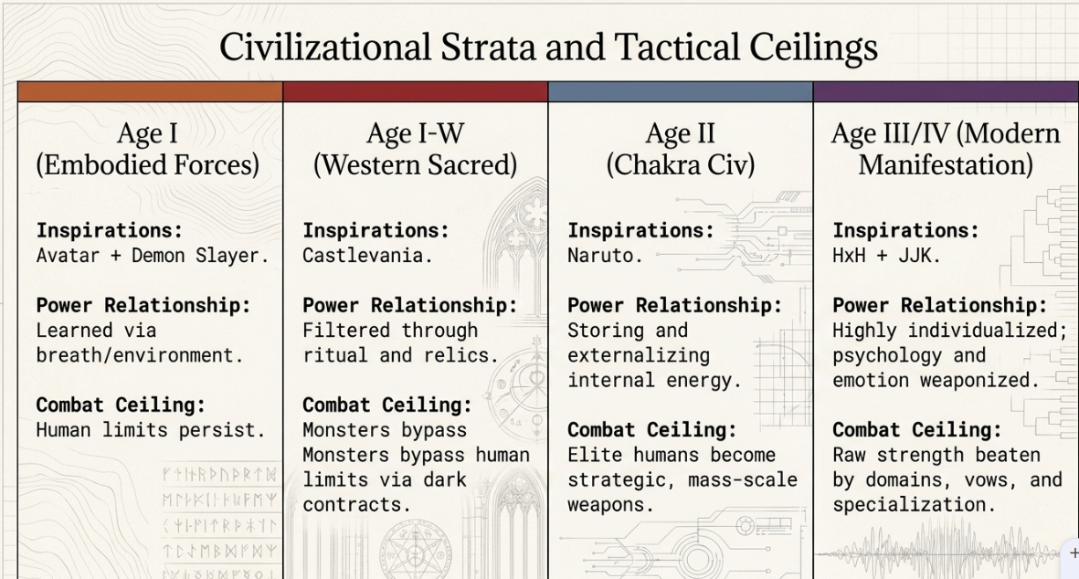
the vision:
- Demon Slayer + Avatar = Breath/Bend age, body-and-element foundation.
- Venia/Nocturne West = gothic human-capped age, steel/blood/holy/moon.
- Naruto = societal chakra age, energy becomes infrastructure.
- Hunter x Hunter = modern Nen age, rules, contracts, associations, nen beasts.
- JJK = modern curse age, special grades as evolved disaster-tier hunters/curses.
- Dark Continent = forbidden postgame layer, not normal squad material.
- All systems = dialects of one Canon Field.
- Gameplay = typing + BST + squad legality + age ceilings + environmental counters, not broken insta-kill matchups.
